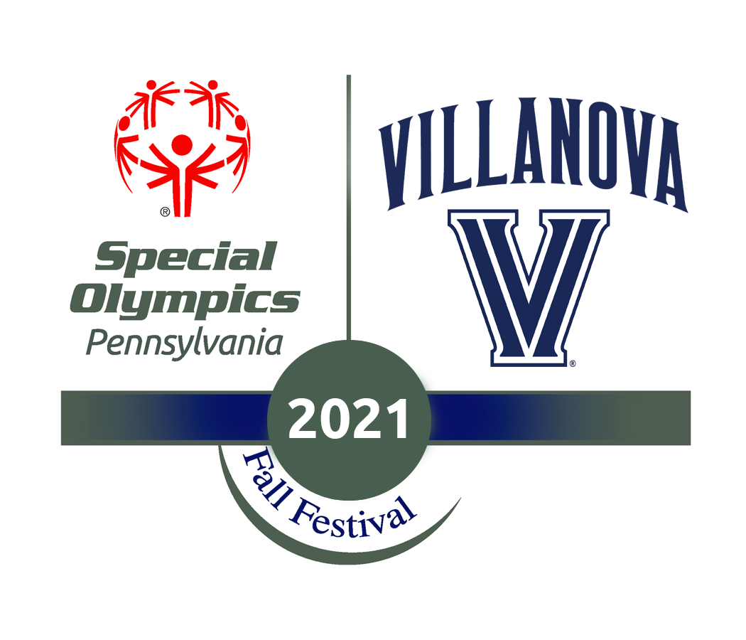
2021 Local Program Host (LPH) Application

Name: ____________________________ Email: ____________________________
Banner ID: ________________________

Please submit answers to the following questions and respond in 250 words or less (per question).

LPHs will be paired with visiting counties from Pennsylvania to act as supporters, allies, and guides to the athletes. LPHs are responsible for creating a fun, energetic, and inclusive atmosphere during the weekend of Fall Fest.

- Villanova's community includes many mission-based organizations. Why have you chosen to support the Mission of Inclusion by applying to the 2021 LPH Program?

- The athlete oath for Special Olympics is, “Let me win. But if I cannot win, let me be brave in the attempt.” How will you help athletes maintain this mindset throughout the weekend of Fall Festival?

- This year’s theme is “Let your colors shine through, be vibrantly you!” Please elaborate on what that theme means to you.

Submissions are due online here by 11:59 pm on September 10th
Interview Sign Ups must be made here after the application is submitted
Do not hesitate to email lph@villanovaspo.com with any questions!

